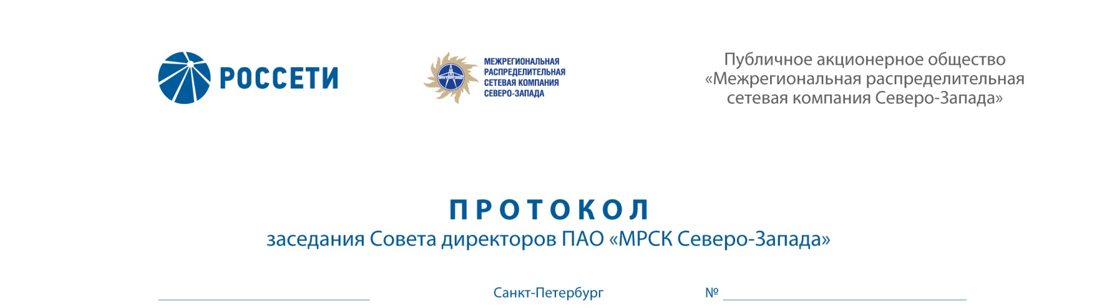
ROSSETI
“INTERREGIONAL DISTRIBUTION GRID COMPANY OF
THE NORTH-WEST”
Public Joint-Stock Company
“Interregional Distribution Grid
Company of the North-West”
MINUTES

Session of the Board of Directors of IDGC of the North-West, PJSC

17.04.2018 276/31
Saint Petersburg

Arrangement form of the session of the Board of Directors of IDGC of the North-West, PJSC – absentee voting (polling).

Chairperson: Chairman of the Board of Directors – Yu.N. Mangarov

Members of the Board of Directors having participated in the session:
- D.B. Akopyan
- N.V. Bogomolov
- A.N. Zharikov
- M.A. Lavrova
- A.V. Letyagin
- M.D. Stepanova
- O.R. Fedorov
- R.A. Filkin
- M.M. Shvankova
- A.V. Shevchuk

The number of the members of the Board of Directors having participated in the session (voting) is 11 persons of the 11 elected members of the Board of Directors.
The quorum required for arrangement of the session of the Board of Directors shall be at least one-half of the number of elected members of the Board of Directors of the Company (Clause 18.12 of the Article 18 of the Charter of IDGC of the North-West, PJSC). The quorum was present.

AGENDA:
- Report of the General Director on implementation of the Plan for Development of the System of Management of the Production Assets of the Company for 2016-2018 for 2017
- Report on the review of the results and elimination of violations found during the on-site inspection of the investment project implementation carried out by the Ministry of Energy of Russia.
- On consideration of the report of General Director of the Company “On documents that confirm commissioning of completed facilities of the Company in 2017 meeting the requirements of the regulatory legal acts and in-house regulations of the Company, including compliance of titles names, availability of phases (start-up facilities, stages) in approved design and estimate documentation and on following the procedure of acceptance of completed facilities by the Company”.
- Report of General Director on compliance with the provisions of the Anticorruption Policy (anticorruption monitoring) of the Company in 2017.
Following the voting results the Board of Directors of IDGC of the North-West, PJSC decided as follows:
On Issue No. 1 on the agenda:
Take under advisement the 2017 Report of General Director on progress in implementation of the Plan for Development of the System of Management of the Production Assets of IDGC of the North-West, PJSC for 2016-2018 in accordance with Appendix No. 1 to this decision of the Board of Directors of the Company.

On Issue No. 2 on the agenda:
1. Take under advisement the Corrective Action Plan aimed to eliminate violations found during the on-site inspection of the investment project “Reconstruction of SS 110/35/10/6 kV “Zapadnaya” implementation carried out by the Ministry of Energy of Russia.
2. Take under advisement the Report on the status of implementation of the Corrective Action Plan aimed to eliminate violations found during the on-site inspection of the investment project “Reconstruction of SS 110/35/10/6 kV “Zapadnaya” implementation in accordance with Appendix No. 2 to this decision of the Board of Directors of the Company.
3. The actions to prevent future violations shall be added to the Corrective Action Plan aimed to eliminate violations found during the on-site inspection of the investment project “Reconstruction of SS 110/35/10/6 kV “Zapadnaya” implementation carried out by the Ministry of Energy of Russia.
On Issue No. 3 on the agenda:
Take under advisement the report “On documents that confirm commissioning of completed facilities of the Company in 2017 meeting the requirements of the regulatory legal acts and in-house regulations of the Company, including compliance of titles names, availability of phases (start-up facilities, stages) in approved design and estimate documentation and on following the procedure of acceptance of completed facilities by the Company” in accordance with Appendix No. 3 to this decision of the Board of Directors of the Company.

On Issue No. 4 on the agenda:
Take under advisement information on the results of anti-corruption monitoring in IDGC of the North-West, PJSC for 2017 in accordance with Appendix No. 4 to this decision of the Board of Directors of the Company.

Protocol generation date – 20.04.2018.

Chairman of the Board of Directors | Yu.N. MANGAROV
Corporate Secretary | L.Yu. NAZARENKO

