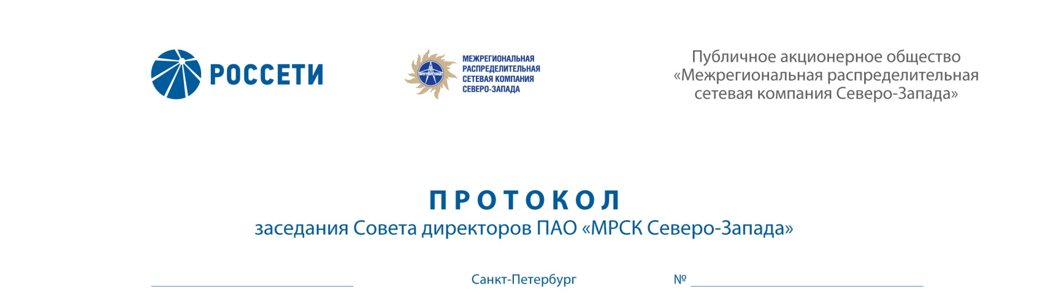
ROSSETI
“INTERREGIONAL DISTRIBUTION GRID COMPANY OF
THE NORTH-WEST”
Public Joint-Stock Company
“Interregional Distribution Grid
Company of the North-West”
MINUTES
Session of the Board of Directors of IDGC of the North-West, PJSC
Saint Petersburg

30.03.2018 275/30

Arrangement form of the session of the Board of Directors of IDGC of the North-West, PJSC – absentee voting (polling).

Chairperson: Chairman of the Board of Directors – Yu.N. Mangarov

Members of the Board of Directors having participated in the session:
- D.B. Akopyan
- N.V. Bogomolov
- A.N. Zharikov
- M.A. Lavrova
- A.V. Letyagin
- M.D. Stepanova
- O.R. Fedorov
- R.A. Filkin
- M.M. Shvankova
- A.V. Shevchuk

The number of the members of the Board of Directors having participated in the session (voting) is 11 persons of the 11 elected members of the Board of Directors.
The quorum required for arrangement of the session of the Board of Directors shall be at least one-half of the number of elected members of the Board of Directors of the Company (Clause 18.12 of the Article 18 of the Charter of IDGC of the North-West, PJSC). The quorum was present.

AGENDA:
- On consideration of the draft amendments to the Investment Program of IDGC of the North-West PJSC for 2016-2025.

ISSUE No. 1: On approval of the draft amendments to the Investment Program of IDGC of the North-West PJSC for 2016-2025.

Issue put to vote:
1. Approve of the draft amendments to the Investment Program of IDGC of the North-West PJSC for 2016-2025 as approved by Order of the Ministry of Energy of Russia No. 906 dated 30.11.2015 (as reworded by Order No. 1333 dated 16.12.2016).
2. Instruct the Sole Executive Body of IDGC of the North-West PJSC:
2.1 to ensure that the draft amendments to be introduced to the investment program of the Company for 2016-2025 are approved by the competent executive authorities of the Russian Federation subject to the laws and regulations of the Russian Federation governing the investment activities.
2.2 to present the report on performance of Clause 2.1 of this decision to the Board of Directors of the Company within 30 calendar days after approval of the draft amendments to the Investment Program of the Company for 2016-2025, in accordance
with the laws and regulations of the Russian Federation governing the investment activities.
Results of voting on the issue concerned:
No. | Full name of member | Voting options
of item | of the Board of Directors of the Company | “For” | “Against” | “Abstained”
1. | Yu.N. Mangarov | “For” | - | -
2. | D.B. Akopyan | “For” | - | -
3. | N.V. Bogomolov | “For” | - | -
4. | A.N. Zharikov | - | - | “Abstained”
5. | M.A. Lavrova | “For” | - | -
6. | A.V. Letyagin | “For” | - | -
7. | M.D. Stepanova | “For” | - | -
8. | O.R. Fedorov | - | - | “Abstained”
9. | R.A. Filkin | - | - | “Abstained”
10. | M.M. Shvankova | “For” | - | -
11. | A.V. Shevchuk | - | - | “Abstained”
Decision on this issue is taken by a majority of votes of members of the Board of Directors of the Company taking part in the meeting (session).
Decision taken.

Following the voting results the Board of Directors of IDGC of the North-West, PJSC decided as follows:
On Issue No. 1 on the agenda:
1. Approve of the draft amendments to the Investment Program of IDGC of the North-West PJSC for 2016-2025 as approved by Order of the Ministry of Energy of Russia No. 906 dated 30.11.2015 (as reworded by Order No. 1333 dated 16.12.2016).
2. Instruct the Sole Executive Body of IDGC of the North-West PJSC:
2.1 to ensure that the draft amendments to be introduced to the investment program of the Company for 2016-2025 are approved by the competent executive authorities of the Russian Federation subject to the laws and regulations of the Russian Federation governing the investment activities.
2.2 to present the report on performance of Clause 2.1 of this decision to the Board of Directors of the Company within 30 calendar days after approval of the draft amendments to the Investment Program of the Company for 2016-2025, in accordance
with the laws and regulations of the Russian Federation governing the investment activities.

Questionnaires completed by members of the Board of Directors are appended to the Minutes.
Protocol generation date – 02.04.2018.

Chairman of the Board of Directors | Yu.N. MANGAROV
Corporate Secretary | L.Yu. NAZARENKO

