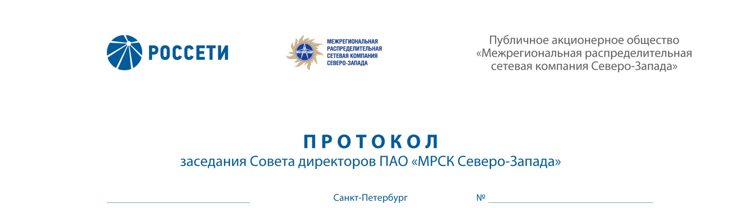
ROSSETI
“INTERREGIONAL DISTRIBUTION GRID COMPANY OF
THE NORTH-WEST”
Public Joint-Stock Company
“Interregional Distribution Grid
Company of the North-West”
MINUTES
Session of the Board of Directors of IDGC of the North-West, PJSC
Saint Petersburg

29.03.2018 274/29

Arrangement form of the session of the Board of Directors of IDGC of the North-West, PJSC – absentee voting (polling).

Chairperson: Chairman of the Board of Directors – Yu.N. Mangarov

Members of the Board of Directors having participated in the session:
- D.B. Akopyan
- N.V. Bogomolov
- A.N. Zharikov
- M.A. Lavrova
- A.V. Letyagin
- M.D. Stepanova
- O.R. Fedorov
- R.A. Filkin
- M.M. Shvankova
- A.V. Shevchuk

The number of the members of the Board of Directors having participated in the session (voting) is 11 persons of the 11 elected members of the Board of Directors.
The quorum required for arrangement of the session of the Board of Directors shall be at least one-half of the number of elected members of the Board of Directors of the Company (Clause 18.12 of the Article 18 of the Charter of IDGC of the North-West, PJSC). The quorum was present.

AGENDA:
- On Approval of IDGC of North-West PJSC Schedule Plan of Measures for reduction of the amount of overdue receivables for electric energy transmission services and settlement of disputes existing as of 01.01.2018.
- On determination of the attitude of the Company’s representatives concerning issues on agendas of general meetings of shareholders and sessions of Boards of Directors of subsidiary companies of IDGC of the North-West PJSC.
- On approval of an in-house document of the Company: Restated Regulations on the Company’s information policy.

Following the voting results the Board of Directors of IDGC of the North-West, PJSC decided as follows:
On Issue No. 1 on the agenda:
1. Approve of IDGC of the North-West PJSC schedule plan of measures for reduction of the amount of overdue receivables for electric energy transmission services and settlement of disputes having arisen as of 01.01.2018 in accordance with Appendix No. 1 to this decision of the Board of Directors of the Company.
2. Take under advisement the information on execution of the Schedule plan of measures for reduction of the amount of overdue receivables for electric energy transmission services and settlement of disputes, generated with regard to the indebtedness having arisen as of the beginning of the previous quarter and previously approved by the Board of Directors of the Company in accordance with Appendix No. 2 to this decision of the Board of Directors of the Company.
3. Take into consideration the information regarding:
- execution of the order of the Board of Directors dated 21.02.2017 (Minutes No. 231/22) as amended by the decision of the Board of Directors dated 28.12.2017 (Minutes No. 263/18) in relation to repayment in Q4 2017 of the amount of outstanding debts from the amount of debts as of 01.01.2017;
- actions performed on new overdue debts and turnover of overdue receivables for electric energy transmission services in Q4 2017;
- work performed with regard to the newly arisen overdue receivables among the debtors accounting for more than 10% of the total newly arisen overdue debt;
- interaction with major debtors accompanied with assessment of payment failure risk, status and assessment of possibility of debt collection through enforcement proceedings;
- implementation of the work plan of IDGC of the North-West PJSC for exercise of the right to claim debts from enterprises and organizations undergoing a bankruptcy procedure.
4. Instruct the Sole Executive Body of the Company to:
4.1. ensure redemption in 2018 of RUR 2,818 mln of overdue receivables out of the amount accumulated as of 01.01.2018, including RUR 607 mln in Q1 2018, RUR 1,094 mln in Q2 2018, RUR 677 mln in Q3 2018, RUR 440 mln in Q4 2018.
4.2. Ensure quarterly reporting on progress in executing the instruction as specified in Clause 4.1 of this decision.

On Issue No. 2 on the agenda:
To instruct representatives of IDGC of the North-West PJSC to vote FOR the following decision on the agenda issue “On approval of the Credit Plan of Pskovenergosbyt OJSC for Q2 2018” at the session of the Board of Directors of Pskovenergosbyt OJSC:
“Approve the Credit Plan of Pskovenergosbyt OJSC in Q2 2018
in accordance with Appendix to the decision of the Board of Directors of the Company”.

On Issue No. 3 on the agenda:
Approve of the restated Regulations on Information Policy of IDGC of the North-West, JSC in accordance with Appendix No. 3 to this decision of the Board of Directors of the Company.

Questionnaires completed by members of the Board of Directors are appended to the Minutes.
Protocol generation date – 30.03.2018.

Chairman of the Board of Directors | Yu.N. MANGAROV
Corporate Secretary | L.Yu. NAZARENKO

